EXPERIMENT 3 .
- AIM:
To design and implement a dimensional data model using Microsoft Power BI by transforming transactional data from the Global Superstore dataset into a Star Schema consisting of Fact and Dimension tables for efficient reporting and analytical processing.
- OBJECTIVES:
- To understand the concepts of Dimensional Modeling and Star Schema.
- To differentiate between Fact Tables and Dimension Tables.
- To transform transactional data into a structured dimensional model using Power BI.
- To create Fact and Dimension tables using Power Query Editor.
- To establish relationships between Fact and Dimension tables.
- To create DAX measures for analytical reporting.
- To validate the Star Schema using Power BI visualizations.
- TOOLS / SOFTWARE REQUIRED:
- Microsoft Power BI Desktop
- Global Superstore Dataset.xlsx
- Power Query Editor – built into Power BI Desktop
- DAX (Data Analysis Expressions)

- DATASET USED: Global Superstore Dataset.xlsx.

- THEORY:
- Dimensional Modeling is a data warehouse design technique used in Business Intelligence systems to organize data for analytical processing and reporting.
- Fact Tables contain measurable business events and numerical values such as Sales, Profit, Quantity, and Discount.
- Dimension Tables contain descriptive attributes used to analyse the facts, such as Customer, Product, Region, and Date.
- Star Schema is a dimensional model in which a central Fact Table is connected to multiple Dimension Tables. It simplifies reporting, improves analytical query performance, and provides a structured model for BI analysis.
- In this experiment, the transactional Orders data is transformed into a central Fact_Sales table, while descriptive information is organized into separate dimension tables.
- The main dimension tables created are Dim_Customer, Dim_Product, Dim_Region, and Dim_Date.
- DAX (Data Analysis Expressions) is used in Power BI to create analytical measures such as Total Sales, Total Profit, Profit Margin, and Average Order Value..

- PROCEDURE:
Part A: Load Dataset
Step 1: Open Microsoft Power BI Desktop.
Launch Microsoft Power BI Desktop.
Step 2: Import the Global Superstore dataset.
Home > Get Data > Excel Workbook
Select: Global Superstore Dataset.xlsx
Click Load.
Step 3: Select the required worksheets.
Import the following worksheets:
- Orders
- Returns
- People
Verify that the imported tables appear in Power BI.
Part B: Identify Fact and Dimension Tables
Step 4: Analyse the Orders table.
Examine the Orders table and identify measurable business attributes such as:
- Sales
- Profit
- Quantity
- Discount
These attributes represent measurable business events and are suitable for the Fact , Table.
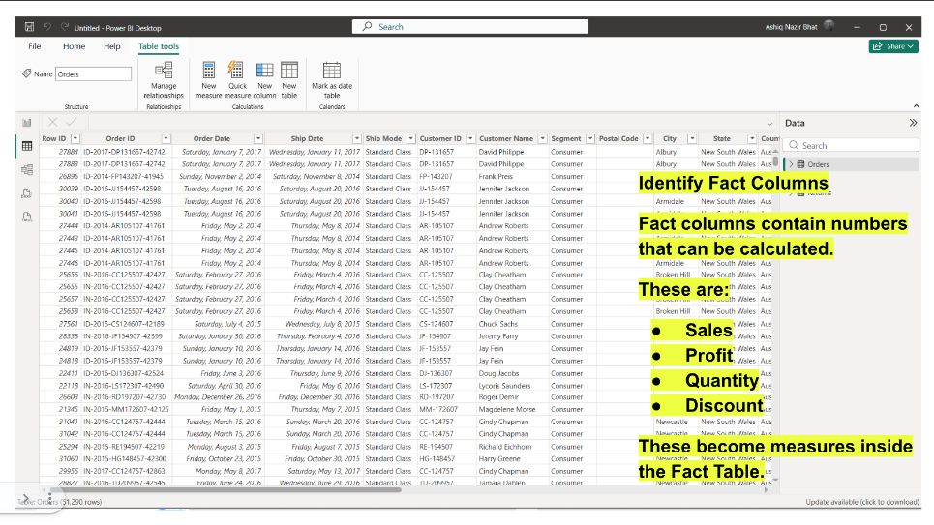
Fig 3.1: Identification of Fact Columns in the Orders Table
Step 5: Identify descriptive attributes.
Identify descriptive attributes related to:
- Customer
- Product
- Region
- Date
These attributes are used to create Dimension Tables.
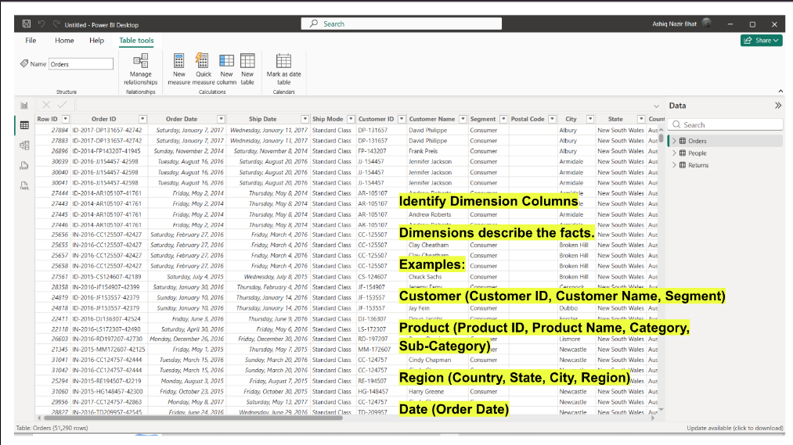
Fig 3.2: Identification of Dimension Attributes in the Orders Table
Step 6: Categorize the data.
Organize the attributes into:
- Fact Table: Fact_Sales
- Dimension Tables: Dim_Customer, Dim_Product, Dim_Region, Dim_Date
This classification forms the basis of the Star Schema.
Part C: Create Dimension Tables
Step 7: Open Power Query Editor.
Home > Transform Data
Step 8: Create Dim_Customer.
Create a customer dimension containing:
- Customer ID
- Customer Name
- Segment
Remove duplicate records from the dimension.
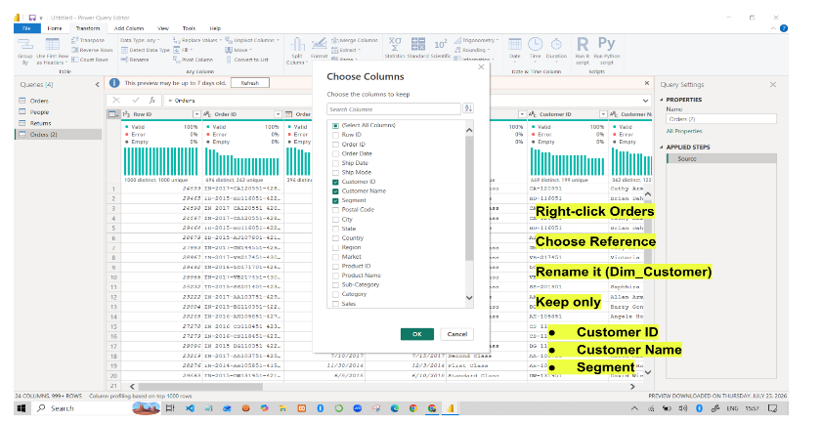
Fig 3.3: Creating the Dim_Customer Table
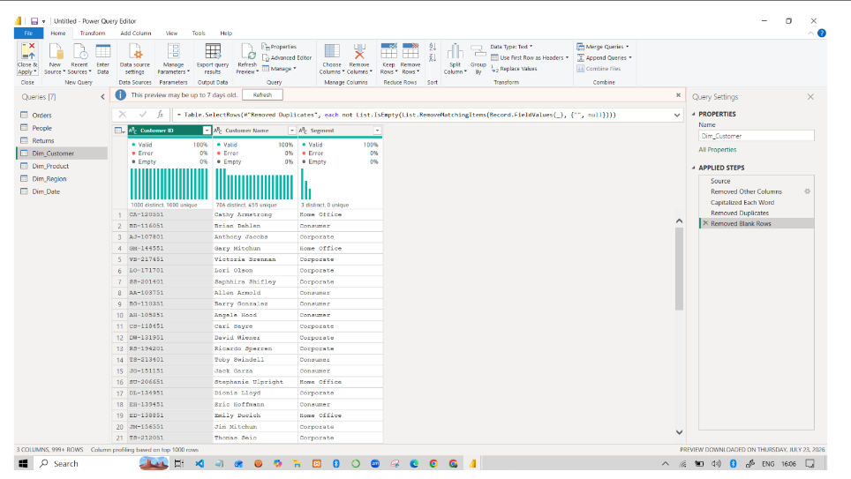
Fig 3.4: Completed Dim_Customer Dimension Table
Step 9: Create Dim_Product.
Create a product dimension containing:
- Product ID
- Product Name
- Category
- Sub-Category
Remove duplicate records.
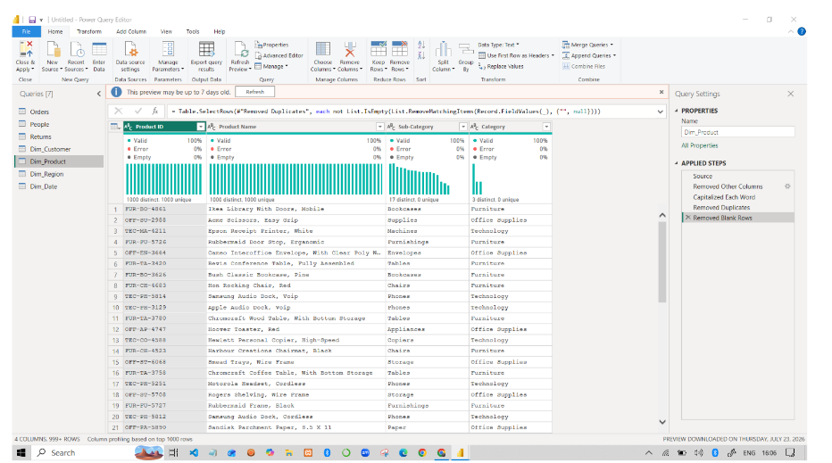
Fig 3.5: Dim_Product Dimension Table
Step 10: Create Dim_Region.
Create a region dimension containing:
- Region
- Country
- State
- City
Remove duplicate records.
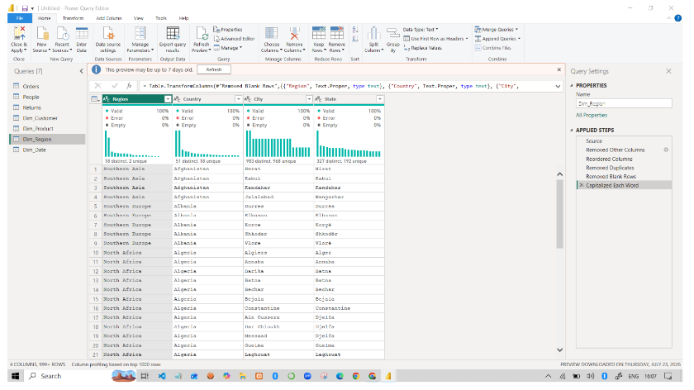
Fig 3.6: Dim_Region Dimension Table
Step 11: Create Dim_Date.
Create a date dimension containing:
- Order Date
- Year
- Quarter
- Month
Ensure that the date-related fields are correctly formatted.
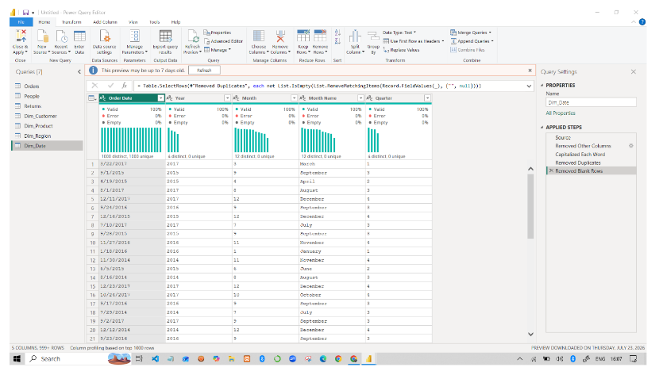
Fig 3.7: Dim_Date Dimension Table
Step 12: Remove duplicate records.
Remove duplicate records from all dimension tables and verify that the key fields . contain unique values.
Part D: Create Fact Table
Step 13: Create Fact_Sales.
Create the central Fact Table containing:
- Order ID
- Customer ID
- Product ID
- Region
- Order Date
- Sales
- Quantity
- Profit
- Discount
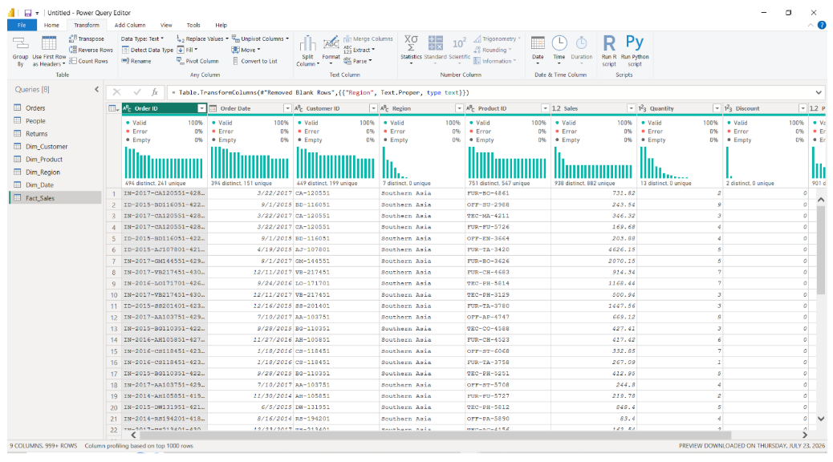
Fig 3.8: Fact_Sales Table
Step 14: Verify key columns.
Verify that all key columns required to establish relationships with the Dimension Tables . are present and correctly formatted.
The resulting Fact_Sales table acts as the central table of the Star Schema.
Part E: Build Star Schema
Step 15: Open Model View.
Select the Model View icon from the left navigation pane in Power BI.
Step 16: Create relationships.
Create relationships between:
- Fact_Sales ↔ Dim_Customer
- Fact_Sales ↔ Dim_Product
- Fact_Sales ↔ Dim_Region
- Fact_Sales ↔ Dim_Date
Configure relationships.
Set the relationships appropriately as Many-to-One, with the Fact Table on the many . side and the corresponding Dimension Table on the one side.
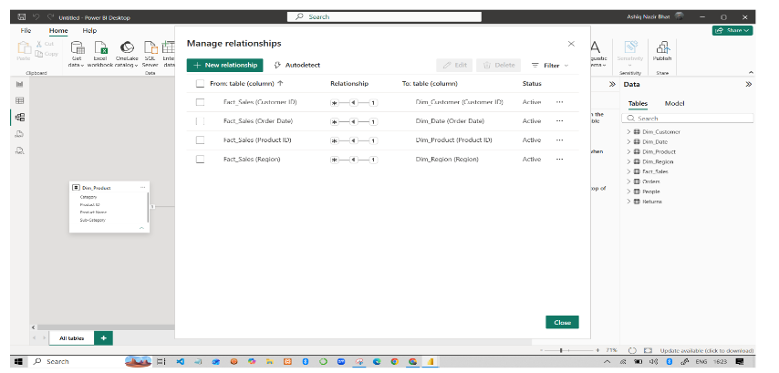
Fig 3.9: Relationships Between Fact_Sales and Dimension Tables
Step 18: Arrange the model.
Arrange the tables visually so that:
Dim_Customer
│
│
Dim_Product ───── Fact_Sales ───── Dim_Region
│
│
Dim_Date
This forms the Star Schema with Fact_Sales at the centre and the Dimension Tables . . surrounding it.
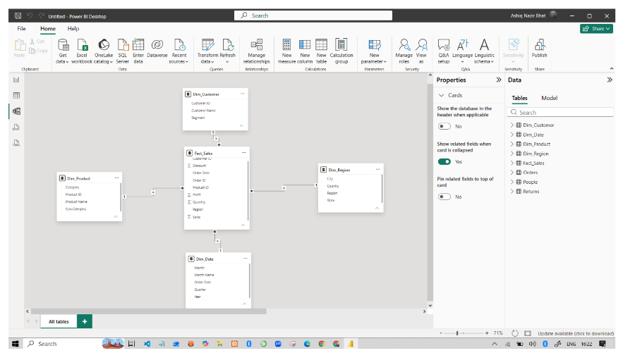
Fig 3.10: Final Star Schema in Power BI Model View
Part F: Validate Model and Create DAX Measures
Step 19: Create Power BI visualizations.
Create visualizations using the dimensional model to analyse the data.
Examples include:
- Sales by Category
- Profit by Region
- Sales Trend by Year
The reference specifies these as examples of visualizations for validating the model.
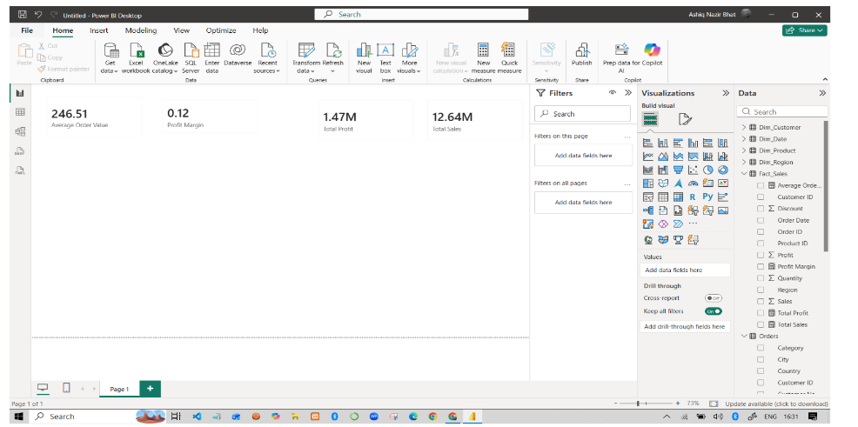
Fig 3.11: Power BI Dashboard Using the Dimensional Model
Step 20: Create DAX measures.
Create the following measures:
  - Total Sales = SUM(Fact_Sales[Sales])
  - Total Profit = SUM(Fact_Sales[Profit])
  - Profit Margin = DIVIDE(SUM(Fact_Sales[Profit]),SUM(Fact_Sales[Sales]))
  - Average Order Value = DIVIDE([Total Sales],DISTINCTCOUNT(Fact_Sales[Order ID]))

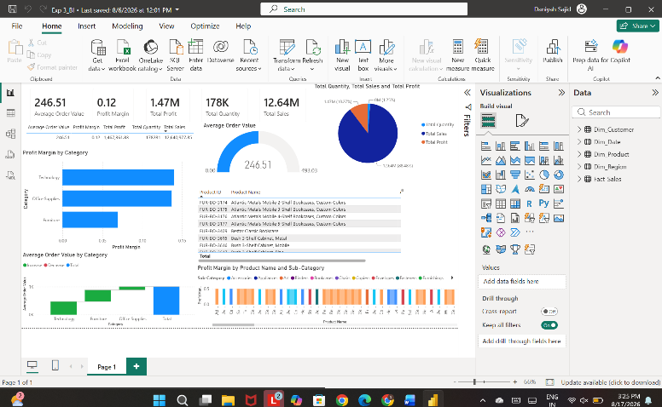
Fig 3.12: DAX Measures and Analytical Results

Step 21: Validate the Star Schema.
Use the created Dimension Tables to filter the Fact Table and verify that the . . . relationships work correctly.
Check that changes in dimensions such as Customer, Product, Region, and Date correctly . affect the corresponding Fact Table data and dashboard visualizations.
- RESULT
Data was successfully extracted from the Global Superstore dataset, transformed using Power Query Editor, and loaded into the Power BI data model. Data cleaning, standardization, relationship creation, and DAX-based metric generation were performed successfully. The final dataset was prepared for reporting and business analysis.
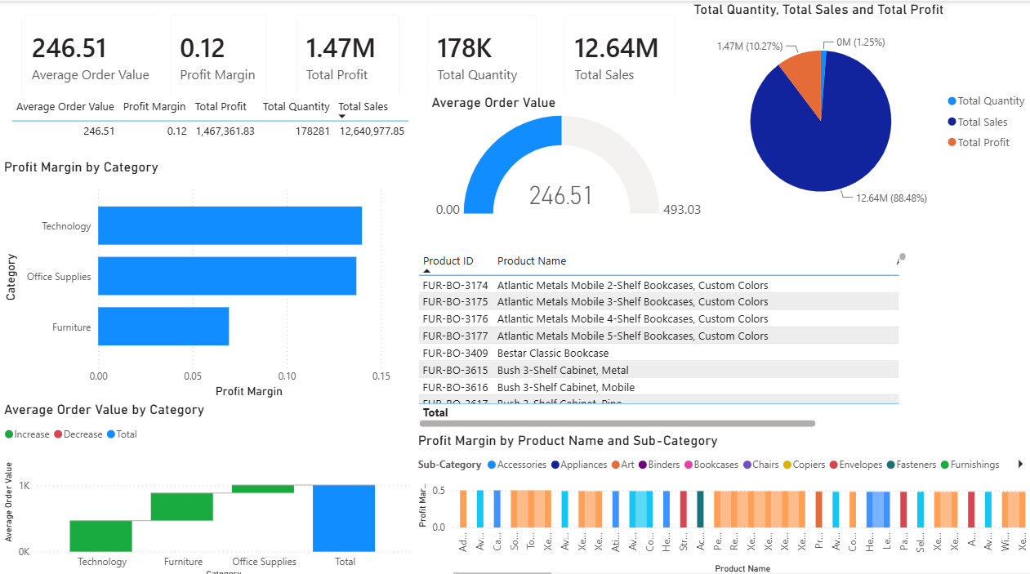
Fig 1.1: Power BI Dashboard

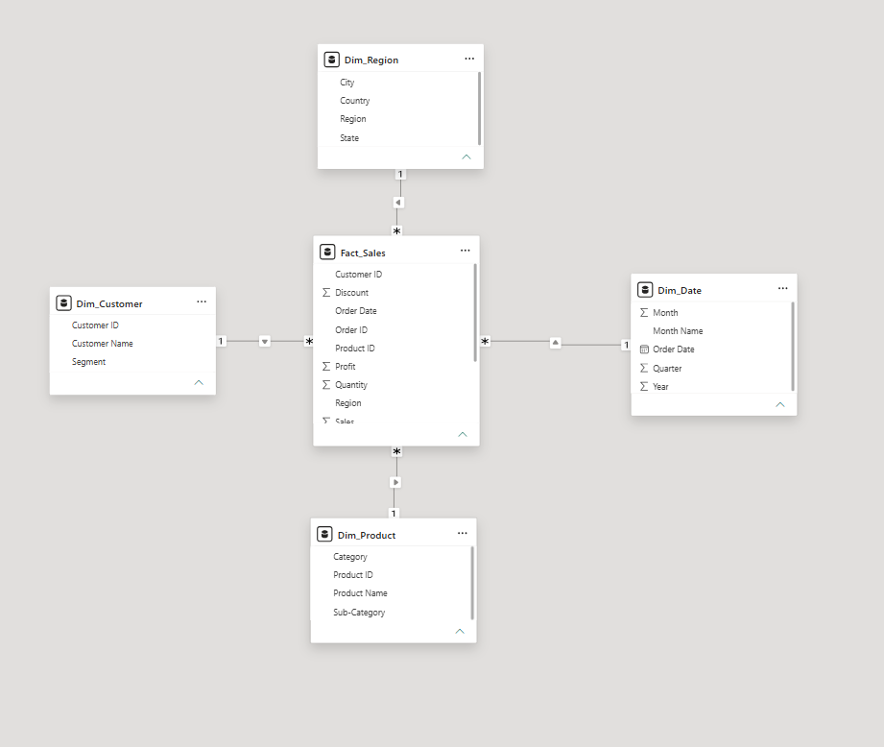
Fig 1.2: Star Schema

- LEARNING OUTCOMES
- Understood the ETL process and its role in Business Intelligence.
- Learned how to extract data from a real-world business dataset using Power BI.
- Gained practical experience with Power Query Editor.
- Learned how to clean, filter, transform, and merge datasets.
- Learned how to handle duplicate records, blank values, and data type inconsistencies.
- Learned how to create relationships between multiple tables in Power BI.
- Learned how to create analytical measures using DAX.
- Understood the use of Total Sales, Total Profit, Profit Margin, and Total Orders measures.
- Learned how to create BI visualizations and dashboards for business analysis.
- Gained practical experience in preparing transformed data for reporting and decision-making.

